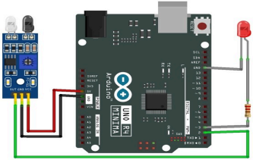

Figure 1: IR Sensor Module and Pin Configuration

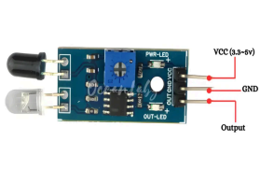
Figure 2: Interfacing of the IR Sensor with the Arduino UNO

